EXP NO: 2
JavaScript Form Validation for Registration Page

AIM:
Write JavaScript to validate the following fields of the Registration page.
a) First Name (Name should contains alphabets and the length
Should not be less than 6 characters).
b) Password (Password should not be less than 6 characters length).
c) E-mail id (should not contain any invalid and must follow the
standard pattern name@domain.com)
d) Mobile Number (Phone number should contain 10 digits only).
e) Last Name and Address (should not be Empty).

CODE:
Validate.html
<!DOCTYPE html>
<html>
<head>
<title>Registration Form</title>
<style>
body {
font-family: Arial, sans-serif;
background-color: #f2f2f2;
display: flex;
flex-direction: column;
align-items: center;
padding: 20px;

}

form {
background-color: white;
padding: 20px;
padding-right: 30px;
border-radius: 10px;
box-shadow: 0 0 10px rgba(0,0,0,0.1);
width: 320px;
}

label {
font-weight: bold;
}

input, textarea {
width: 100%;
margin-top: 5px;
margin-bottom: 10px;
padding: 8px;
border: 1px solid #ccc;
border-radius: 6px;
}

.error-message {
color: red;
font-size: 13px;
margin-bottom: 10px;
}

input[type="submit"] {
background-color: #4CAF50;
color: white;
cursor: pointer;
font-weight: bold;
border: none;
}

input[type="submit"]:hover {
background-color: #45a049;
}

h1 {
margin-bottom: 20px;
}
</style>
</head>
<body>
<h1>Registration Form</h1>
<form name="RegForm" onsubmit="return validateForm()">
<label for="firstname">First Name:</label>
<input type="text" id="firstname" name="firstname" required>
<span id="firstname-error" class="error-message"></span>

<label for="lastname">Last Name:</label>
<input type="text" id="lastname" name="lastname" required>
<span id="lastname-error" class="error-message"></span>

<label for="password">Password:</label>
<input type="password" id="password" name="password" required>
<span id="password-error" class="error-message"></span>

<label for="email">Email:</label>
<input type="text" id="email" name="email" required>
<span id="email-error" class="error-message"></span>

<label for="phone">Phone Number:</label>
<input type="tel" id="phone" name="phone" required>
<span id="phone-error" class="error-message"></span>

<label for="address">Address:</label>
<textarea id="address" name="address" required></textarea>
<span id="address-error" class="error-message"></span>

<input type="submit" value="Submit">
</form>

<script>
function validateForm() {
let isValid = true;

let firstname = document.getElementById("firstname").value.trim();
let lastname = document.getElementById("lastname").value.trim();
let password = document.getElementById("password").value;
let email = document.getElementById("email").value.trim();
let phone = document.getElementById("phone").value.trim();
let address = document.getElementById("address").value.trim();

const firstnameError = document.getElementById("firstname-error");
const lastnameError = document.getElementById("lastname-error");
const passwordError = document.getElementById("password-error");
const emailError = document.getElementById("email-error");
const phoneError = document.getElementById("phone-error");
const addressError = document.getElementById("address-error");

firstnameError.textContent = "";
lastnameError.textContent = "";
passwordError.textContent = "";
emailError.textContent = "";
phoneError.textContent = "";
addressError.textContent = "";

if (!/^[A-Za-z]{6,}$/.test(firstname)) {
firstnameError.textContent = "First Name must be alphabetic and at least 6 characters.";
isValid = false;
}

if (lastname === "") {
lastnameError.textContent = "Last Name should not be empty.";
isValid = false;
}

if (password.length < 6) {
passwordError.textContent = "Password must be at least 6 characters.";
isValid = false;
}

const emailPattern = /^[a-zA-Z0-9._%+-]+@[a-zA-Z0-9.-]+\.[a-zA-Z]{2,}$/;
if (!emailPattern.test(email)) {
emailError.textContent = "Invalid email format (e.g., name@domain.com).";
isValid = false;
}

if (!/^\d{10}$/.test(phone)) {
phoneError.textContent = "Phone number must be exactly 10 digits.";
isValid = false;
}

if (address === "") {
addressError.textContent = "Address should not be empty.";
isValid = false;
}

if (isValid) {
alert("Registered successfully!");
}

return isValid;
}
</script>
</body>
</html>

OUTPUT:
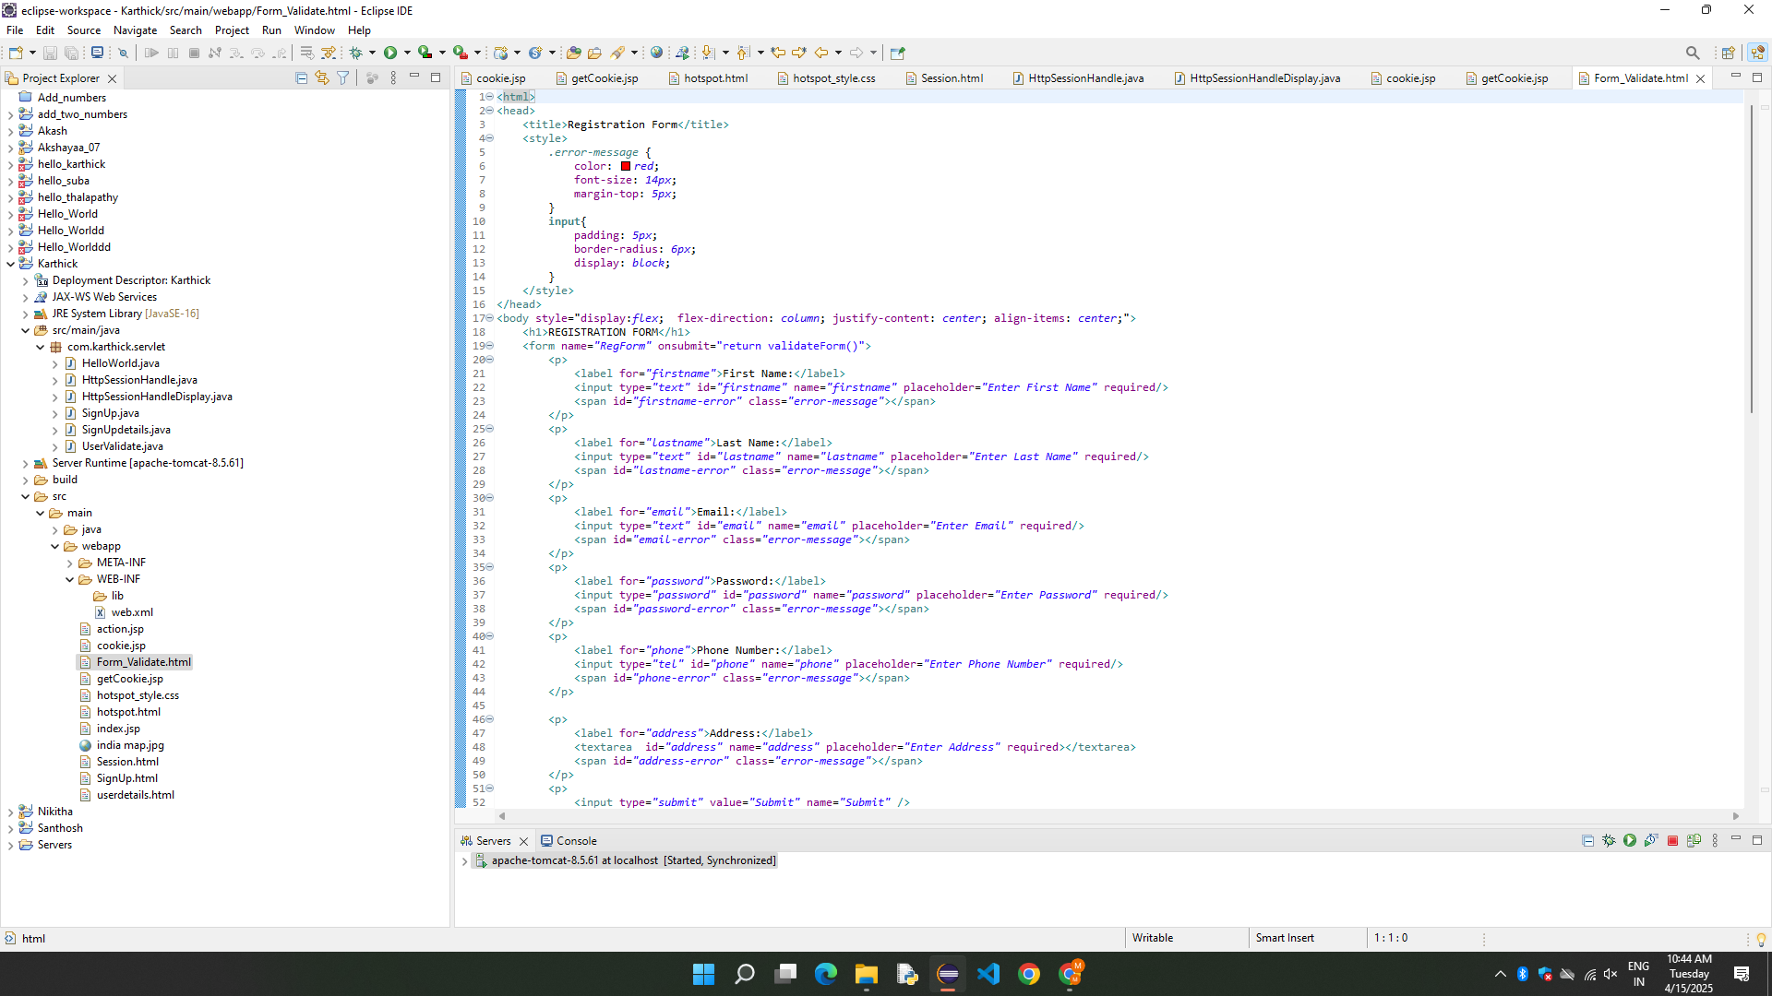
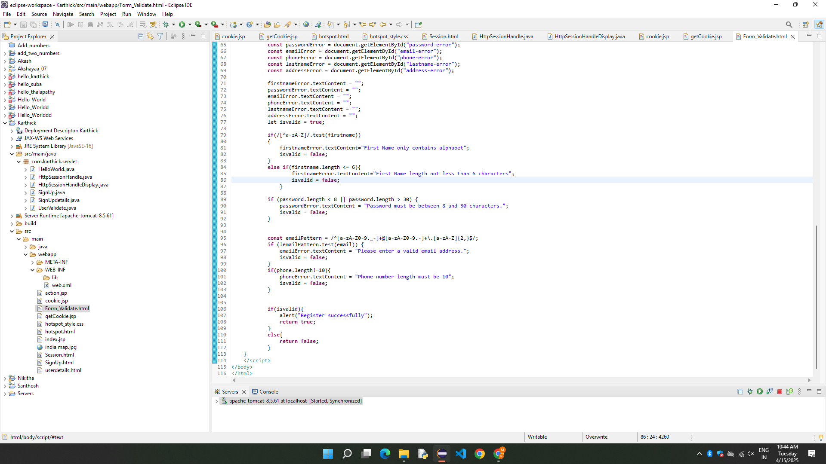

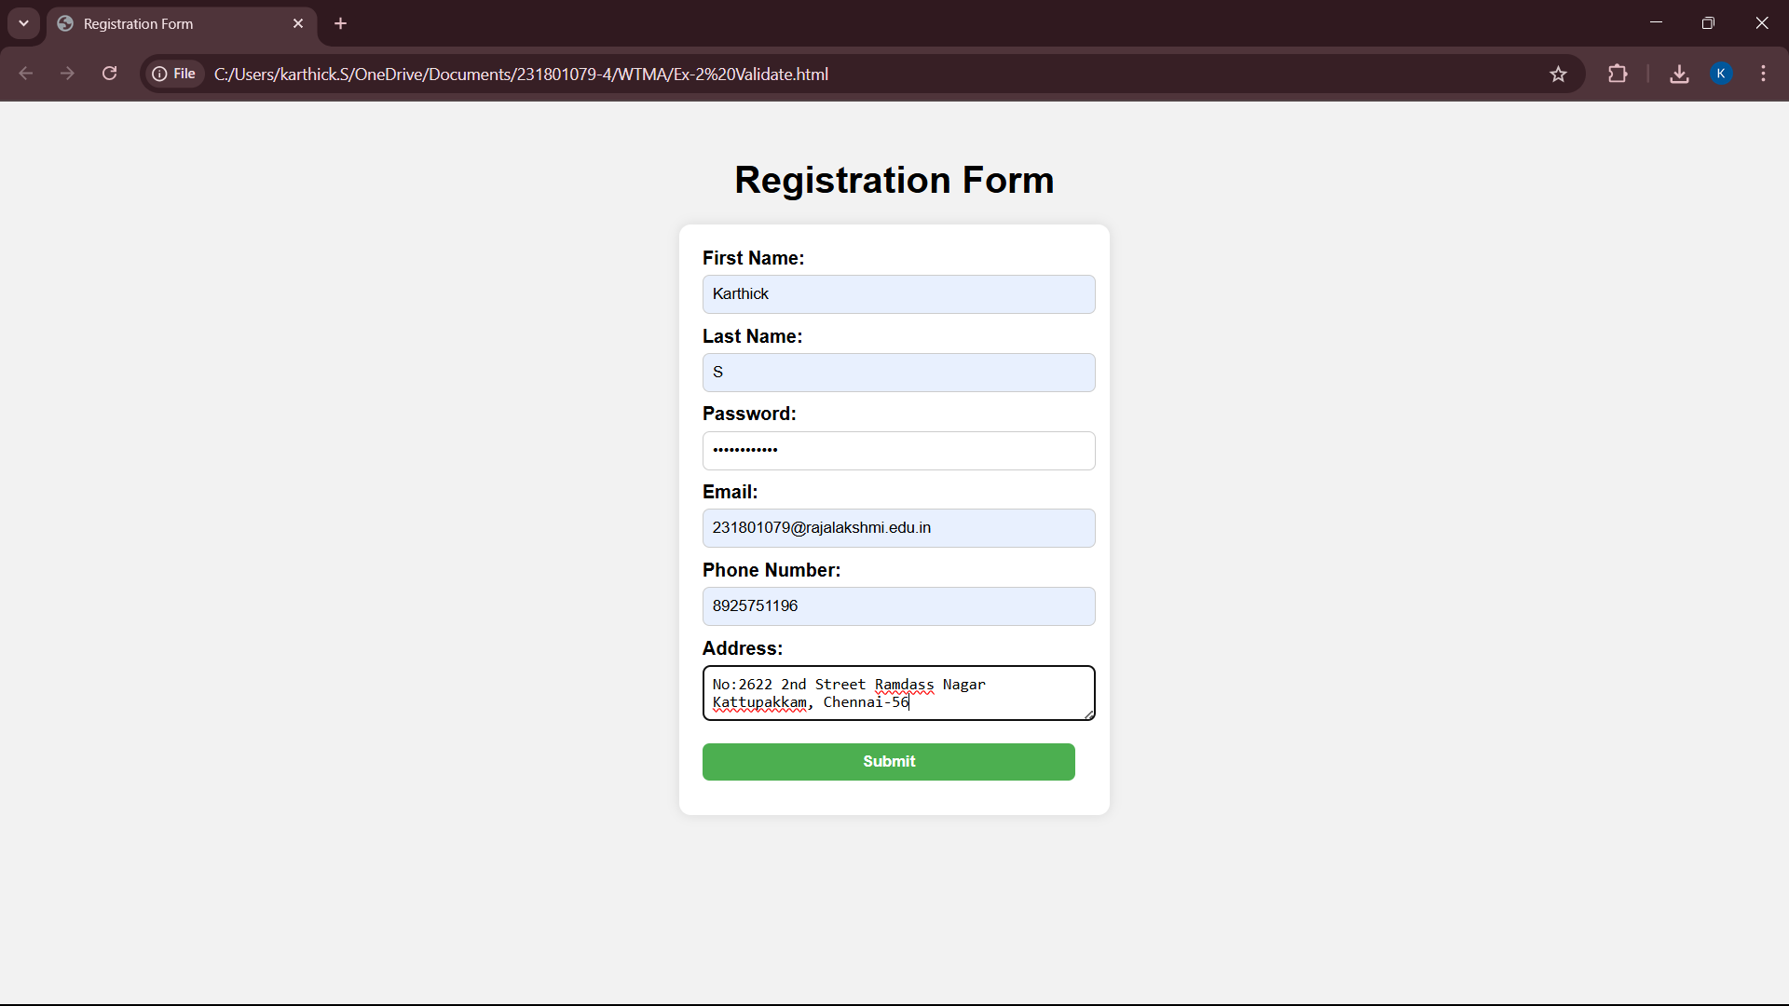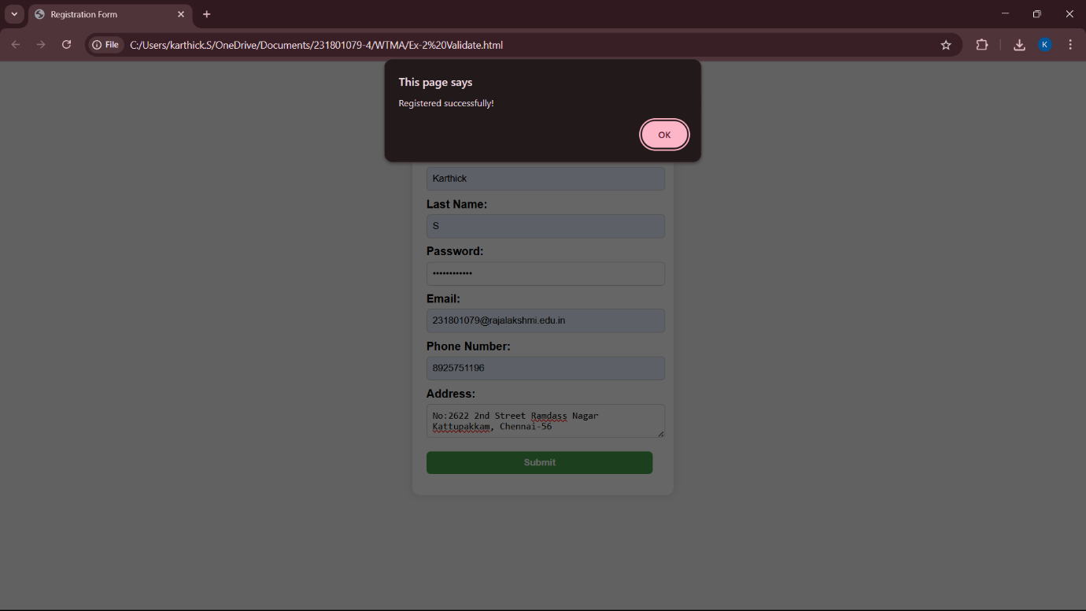

RESULT:
The Registration form with required validation is successfully implemented.

